**BANK LOAN ANALYSIS PROJECT**



The Bank Loan Analysis is a project which analyses the data to know the important information and visualizes it to see the figures easily.

The dataset consists of various information about the loan applications:

1. **Loan ID** is a unique identifier assigned to each loan application.
2. **Address State** indicates the borrower's location.
3. **Employee length** is the applicant's term in a particular company.
4. **Employee Title** specifies the borrower's occupation or job title.
5. **Grade** represents a risk classification assigned to the loan based on creditworthiness.
6. **Sub-grade** refines the risk assessment within a grade.
7. **Home Ownership** indicates the borrower's housing status.
8. **Issue Date** marks the loan's origination date.
9. **Last Credit Pull Date** records when the borrower's credit report was last accessed.
10. **Last Payment Date** marks the most recent loan payment received.
11. **Loan Status** indicates the current state of the loan (e.g., fully paid, current, charged off).
12. **Next Payment Date** estimates the date of the next loan payment.
13. **Purpose** specifies the reason for the loan
14. **Term** defines the duration of the loan in months.
15. **Verification Status** indicates whether the borrower's financial information has been verified.
16. **Annual Income**
17. **DTI** measures the borrower's debt burden relative to income.
18. **Instalment** is the fixed monthly payment amount for loan repayment, including principal and interest.
19. **Interest Rate**
20. **Loan Amount**

**Steps Taken:**

1. **Data Cleaning** and **Results Check** (with the figures shown on Tableau Dashboard) in **Alteryx.**
2. **Data Visualisation** in **Tableau** – Overall Analysis, Regional Analysis, and Loan Status Analysis.
3. **Total Loan Applications**

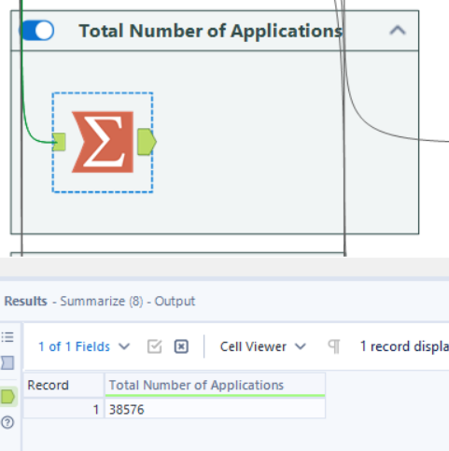

1. **Total Lent Amount**

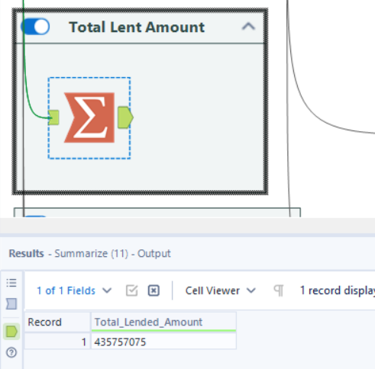

1. **Total Amount Received**

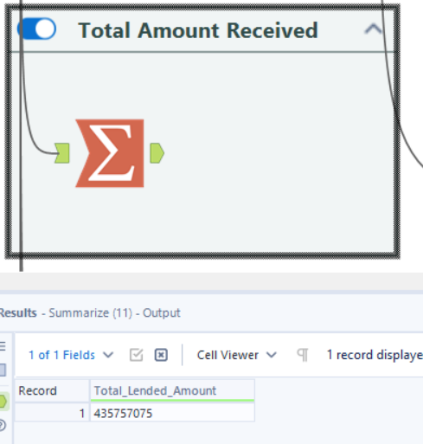

1. **Average Interest Rate (Month-wise)**

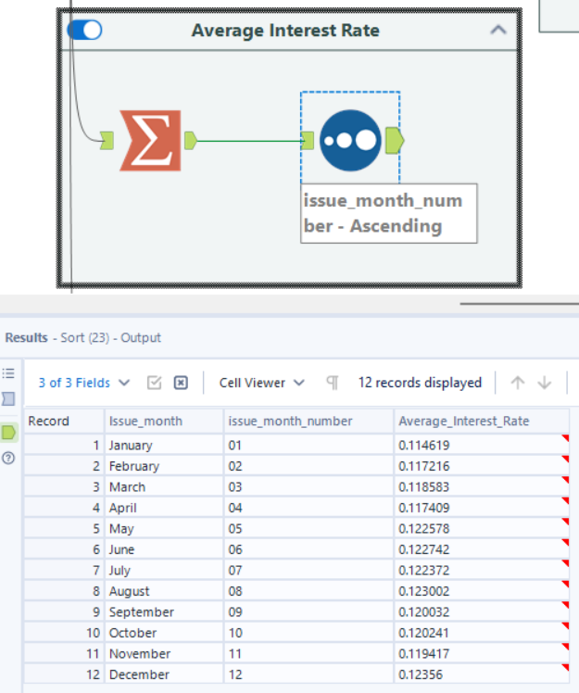

1. **Average Debt-to-Income Ratio (Month-wise)**

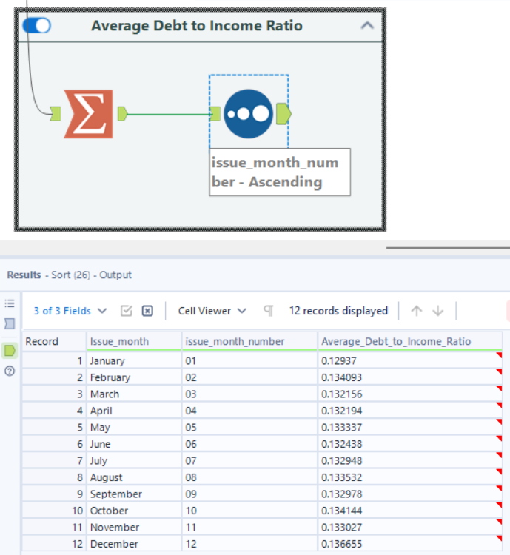

1. **Total Applications in Each Home Ownership Category**

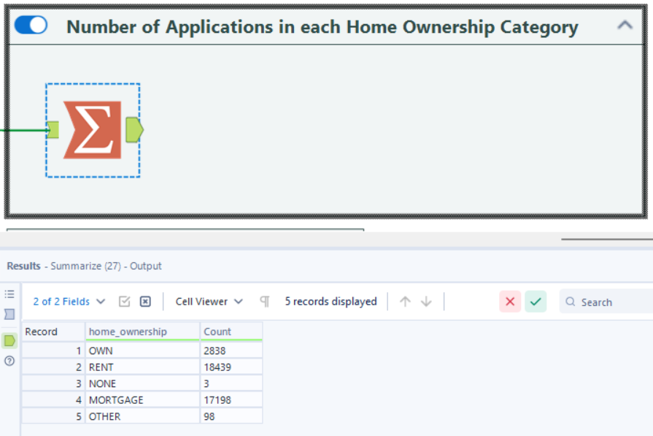

1. **Applications by Loan Status**

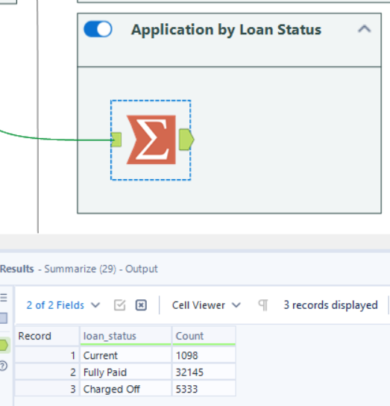

1. **Applications by Verification Status**

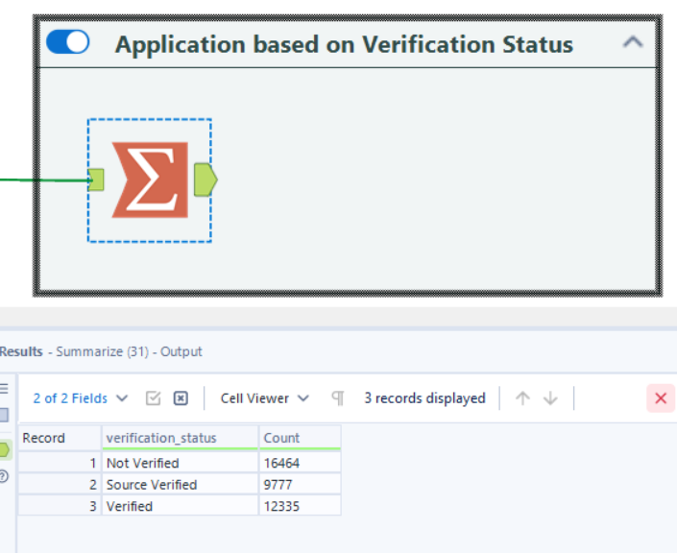

1. **Applications based on the Term of Employment**

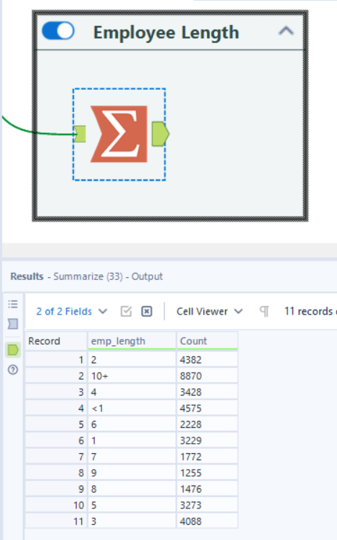

1. **Region-Wise All Months Calculations**

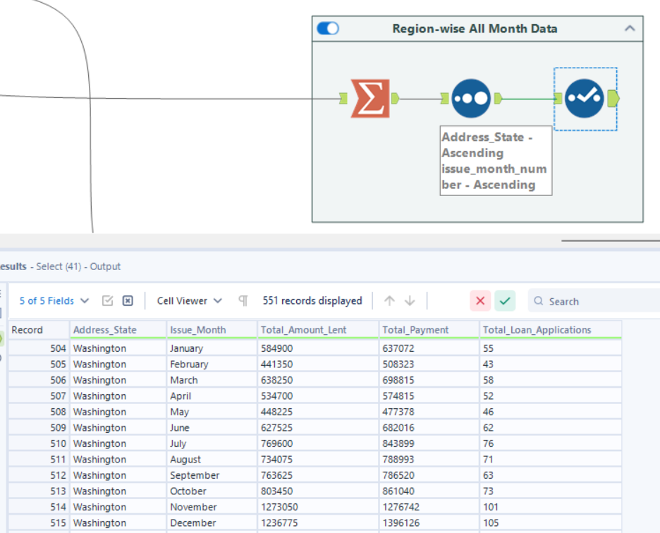

1. **Region Wise Loan Status Data**

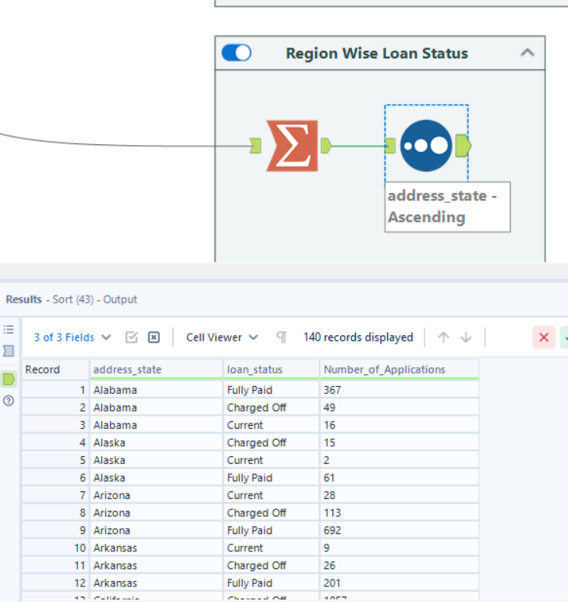

1. **Region Wise Home Ownership Data**

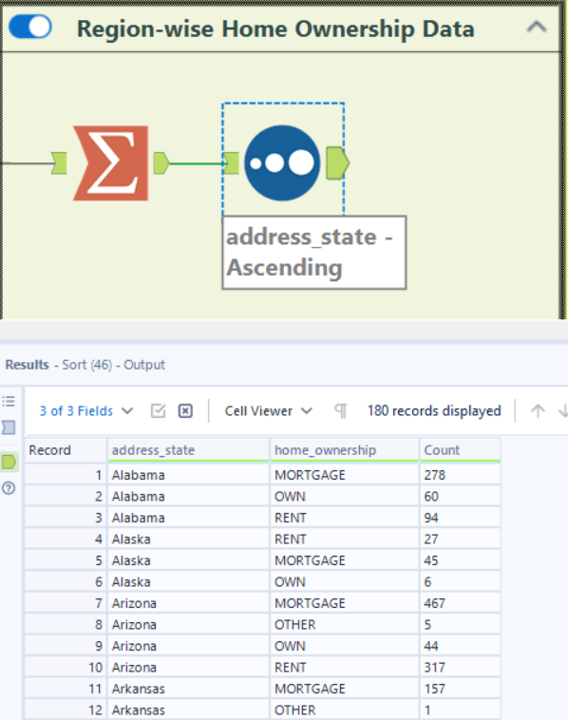

1. **Region-Wise Employee Length Data**

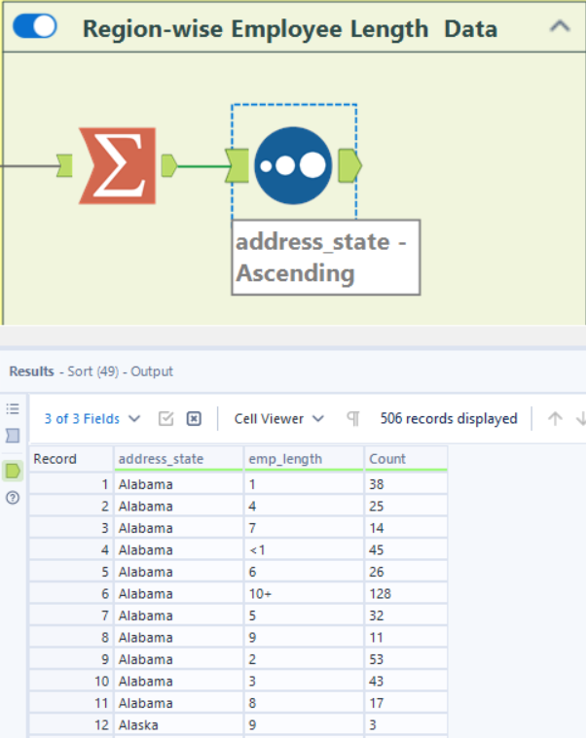

1. **Loan Status vs Grade**

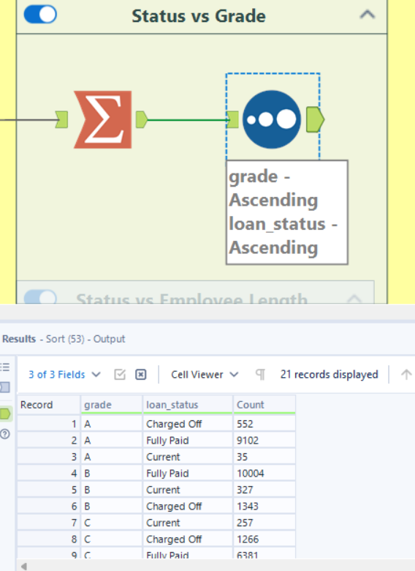

1. **Loan Status vs Employee Length**

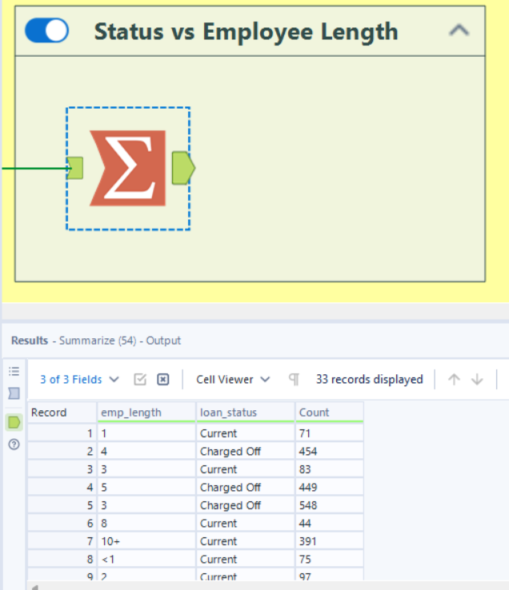

1. **Loan Status vs Verification Status**

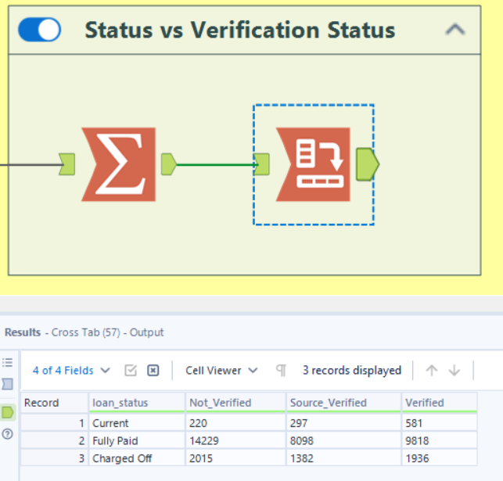

1. **Loan Status vs Home Ownership**

